**1. GUAN W (2020) NEJM 1099 patients (China)**

<https://www.nejm.org/doi/full/10.1056/NEJMoa2002032>

The incubation period was defined as the interval between the potential earliest date of contact of the transmission source (wildlife or person with suspected or confirmed case) and the potential earliest date of symptom onset (i.e., cough, fever, fatigue, or myalgia).

The median incubation period was 4 days (interquartile range, 2 to 7).

**2. WANG D (2020) JAMA 138 patients (China)**

<https://jamanetwork.com/journals/jama/fullarticle/2761044>

Time from onset of symptoms to, median (IQR), Total, ICU, Non-ICU

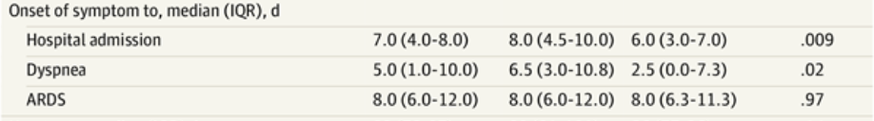

**3. ZHOU F (2020) 191 patients (China)**

<https://www.thelancet.com/pdfs/journals/lancet/PIIS0140-6736(20)30566-3.pdf>

Total, Non-survivor, survivor

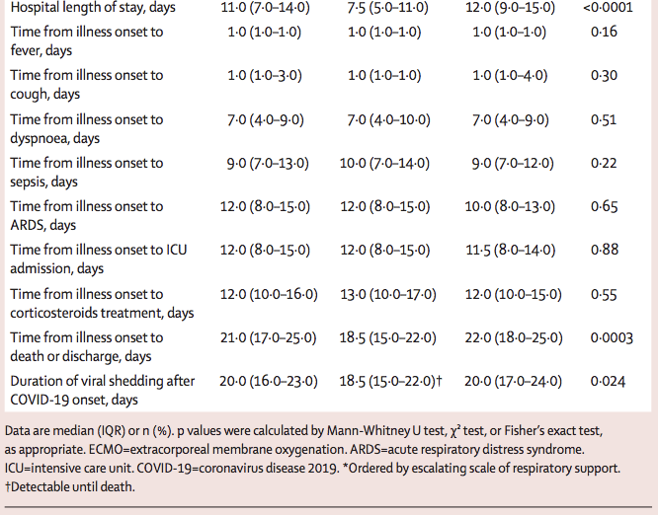

**4. CHEN T (2020) China 113 patients that died and 161 patients who recovered.**

<https://www.bmj.com/content/bmj/368/bmj.m1091.full.pdf>

Total, deaths, recovered patients



**5. LI Q (2020) China 425 patients**

<https://www.nejm.org/doi/full/10.1056/NEJMoa2002032>

We examined data on exposures among 10 confirmed cases, and we estimated the **mean incubation period to be 5.2 days (95% confidence interval [CI], 4.1 to 7.0); the 95th percentile of the distribution was 12.5 days (95% CI, 9.2 to 18)** ([Figure 2A](https://www.nejm.org/doi/full/10.1056/NEJMoa2001316)). We obtained information on 5 clusters of cases, shown in [Figure 3](https://www.nejm.org/doi/full/10.1056/NEJMoa2001316). On the basis of the dates of illness onset of 6 pairs of cases in these clusters, we estimated that the serial interval distribution had a mean (±SD) of 7.5±3.4 days (95% CI, 5.3 to 19) ([Figure 2B](https://www.nejm.org/doi/full/10.1056/NEJMoa2001316)).

The **duration from illness onset to first medical** visit for 45 patients with illness onset before January 1 was estimated to have a **mean of 5.8 days (95% CI, 4.3 to 7.5),** which was similar to that for 207 patients with illness onset between January 1 and January 11, with a **mean of 4.6 days (95% CI, 4.1 to 5.1)** ([Figure 2C](https://www.nejm.org/doi/full/10.1056/NEJMoa2001316)). The mean duration from **onset to hospital admission was estimated to be 12.5 days (95% CI, 10.3 to 14.8)** among 44 cases with illness onset before January 1, which was longer than that among 189 patients with illness onset between January 1 and 11 **(mean, 9.1 days; 95% CI, 8.6 to 9.7)** ([Figure 2D](https://www.nejm.org/doi/full/10.1056/NEJMoa2001316)).

**6. Bi Q (2020) China 1286 patients (Many more parameters but need to check the paper to see what is needed specifically)**

<https://www.thelancet.com/action/showPdf?pii=S1473-3099%2820%2930287-5>

Based on 183 cases with a well-defined period of exposure and symptom onset (appendix 2 p 8), we estimated the **median incubation period for COVID-19 to be 4·8 days (95% CI 4·2–5·4**; figure 1, appendix 2 p 2), and estimated that 95% of **those who develop symptoms will do so within 14·0 days (95% CI 12·2–15·9) of infection.** We estimated that about 5·0% of cases who develop symptoms would not show symptoms until 14 days after infection.

**Based on 228 cases with known outcomes, we estimated that median time to recovery was 20·8 days (95% CI 20·1–21·5).** We estimated that the median time to recovery was 22·4 days (95% CI 20·8–24·1) in individuals aged 50–59 years, and was estimated to be significantly shorter in younger adults (eg, 19·2 days in individuals aged 20–29 years; appendix 2 pp 3, 10).

**Compared to cases with mild symptoms, those with severe symptoms had a 41% (95% CI 24–60) longer time to recovery** (appendix 2 p 3). As of Feb 22, 2020, three cases had died. These deaths occurred 35–44 days from symptom onset and 27–33 days from confirmation

**7. RICHARDSON S (2000) USA 5700 patients**

<https://jamanetwork.com/journals/jama/fullarticle/2765184>

